Persistent 2

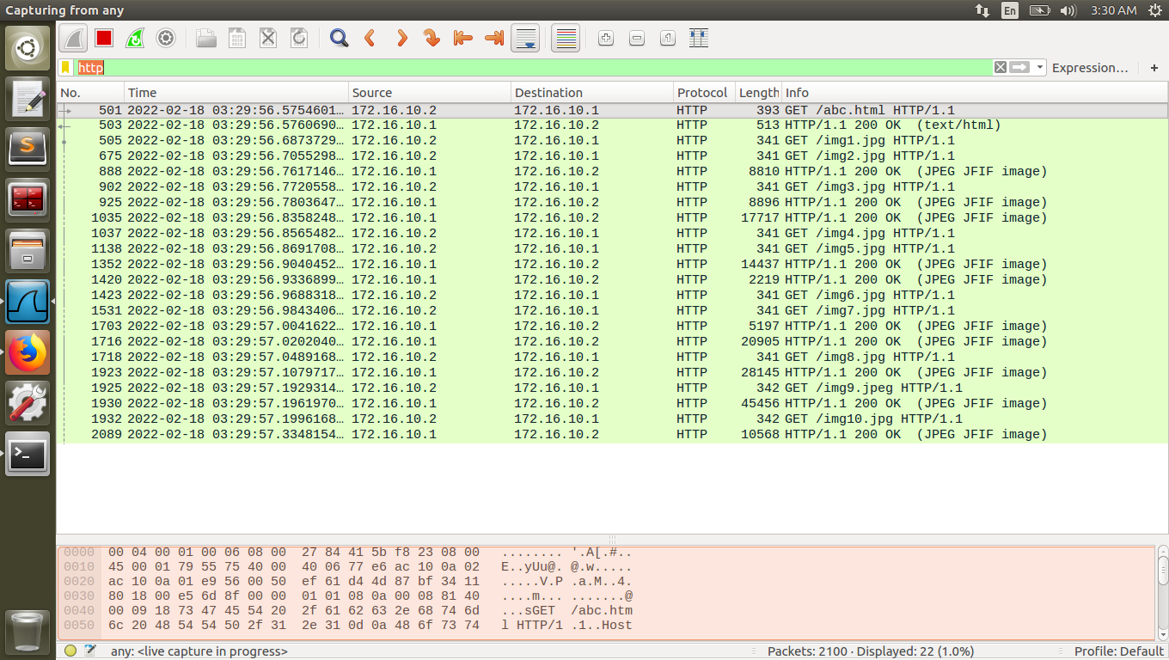

Time difference = 57.334 – 56.575 = 0.759

Persistent 4

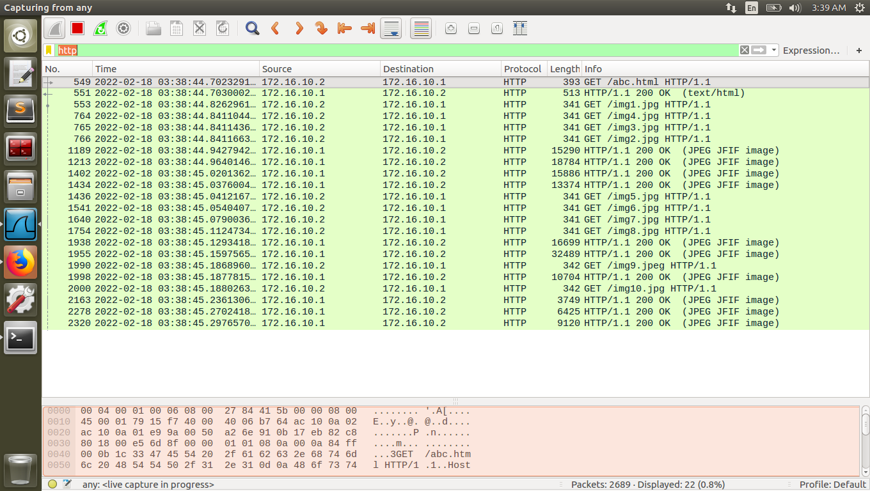

Time difference = 45.297 – 44.702 = 0.595

Persistent 10

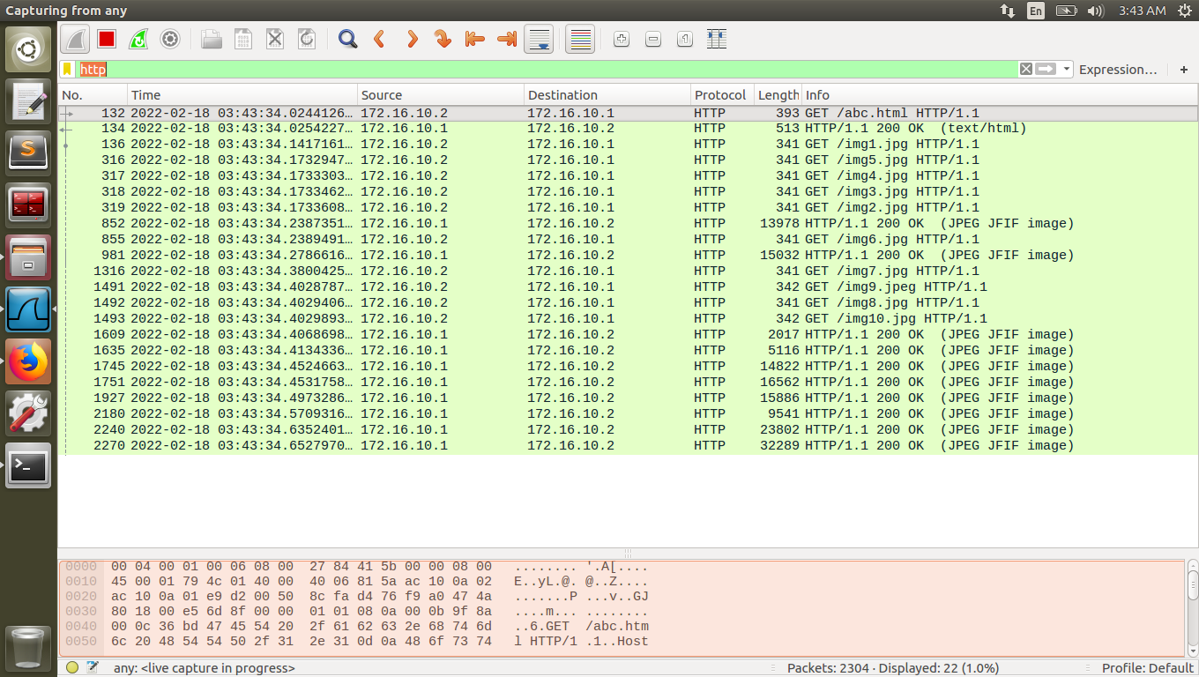

Time difference = 34.652– 34.024 = 0.628

Persistent 6

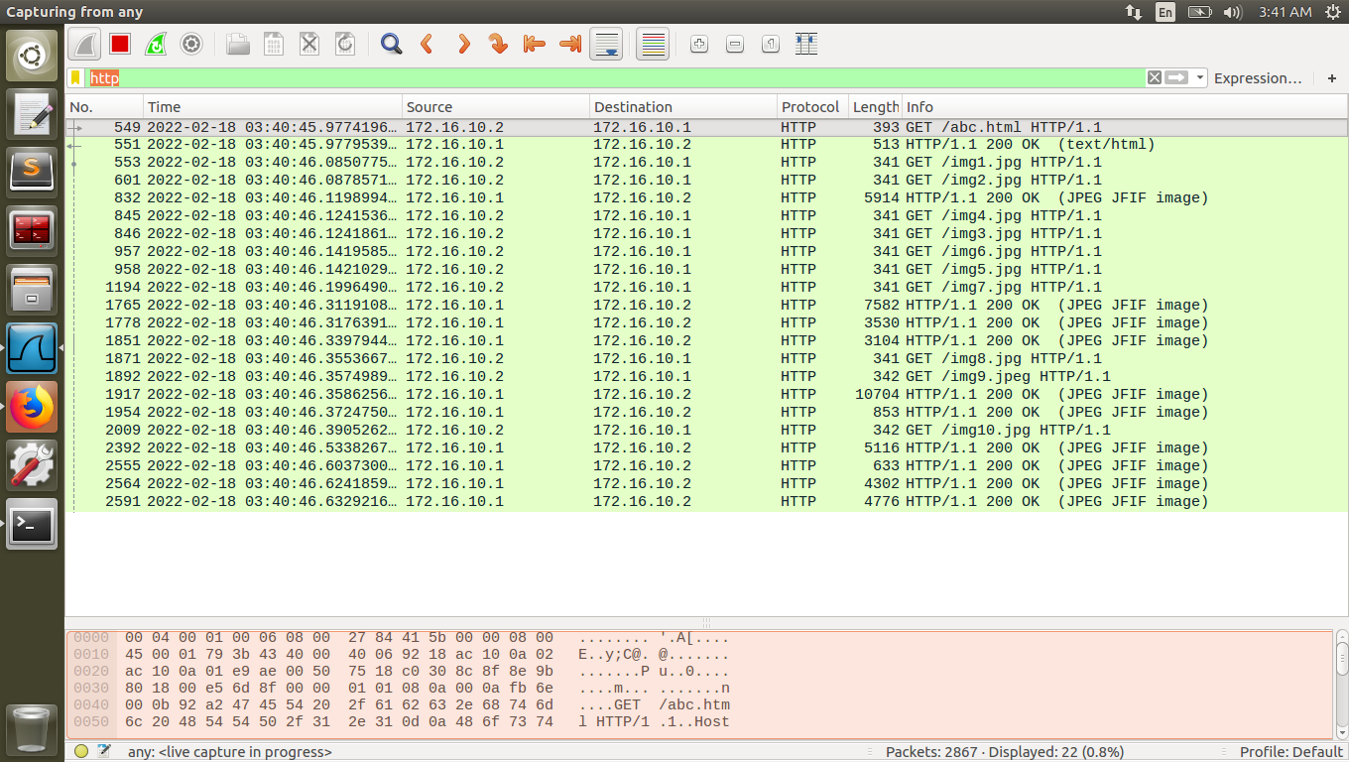

Time difference = 46.632 – 45.977 = 0.655

Nonpersistent

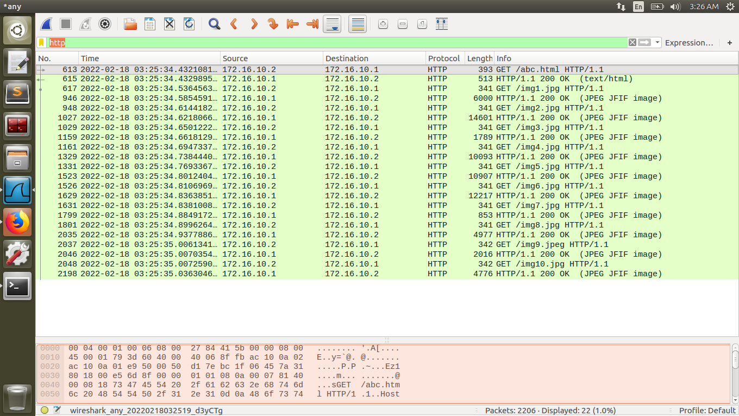

Time difference = 35.036 – 34.432 = 0.604